Purpose:
The El Norte Parkway Improvement Project will construct new improvements in the area of the Escondido Creek Channel, bringing El Norte Parkway to its ultimate width to improve traffic flow. The Project will also add landscaped medians along El Norte Parkway between El Norte Hills Place and East Valley Parkway. A signalized pedestrian crossing will be added to increase pedestrian safety and welcome users at the existing bike path where the Escondido Creek Trail crosses El Norte Parkway. The new trailhead entry sign will be installed where the Escondido Creek Trail crosses El Norte Parkway.
Schedule:
September 2019 – March 2020
Features:
- Construction of second bridge over the Escondido Creek
- Addition of another lane in each direction on El Norte Parkway
- Construction of landscaped medians
- Undergrounding of existing overhead utilities
- Signalized pedestrian crossing
- Escondido Creek trailhead entry sign
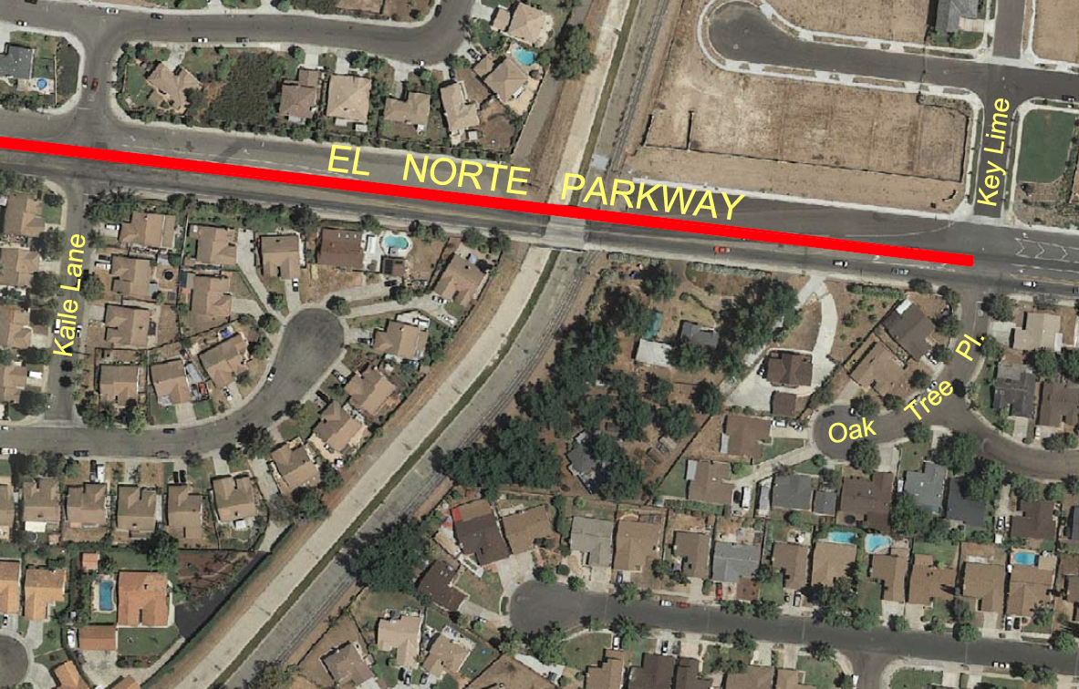
Location Map
Project Update:
October 2019 – Update
Figure 1 represents a before picture the Escondido Creek Channel under El Norte Parkway, and measures taken for Storm Water Pollution Prevention Plan (SWPPP). Progress on the second bridge installation has started with the demolition of the existing channel lining (Figure 2) for construction of bridge abutments and wingwalls.
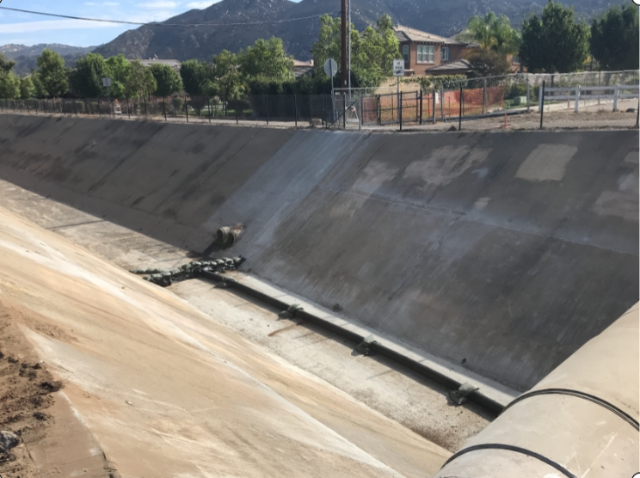
Figure 1 –Before Demolition
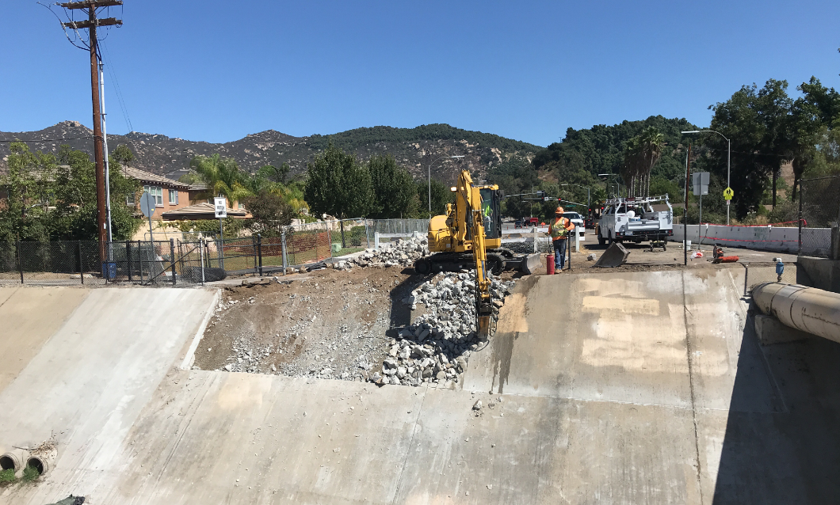
Figure 2 -Demolition
Twenty-two piles (Figure 3) were driven with a diesel engine powered pile hammer (Figure 4) to a depth of 75 ft. to support the second bridge. Figure 5 provides an illustration of the driven piles.
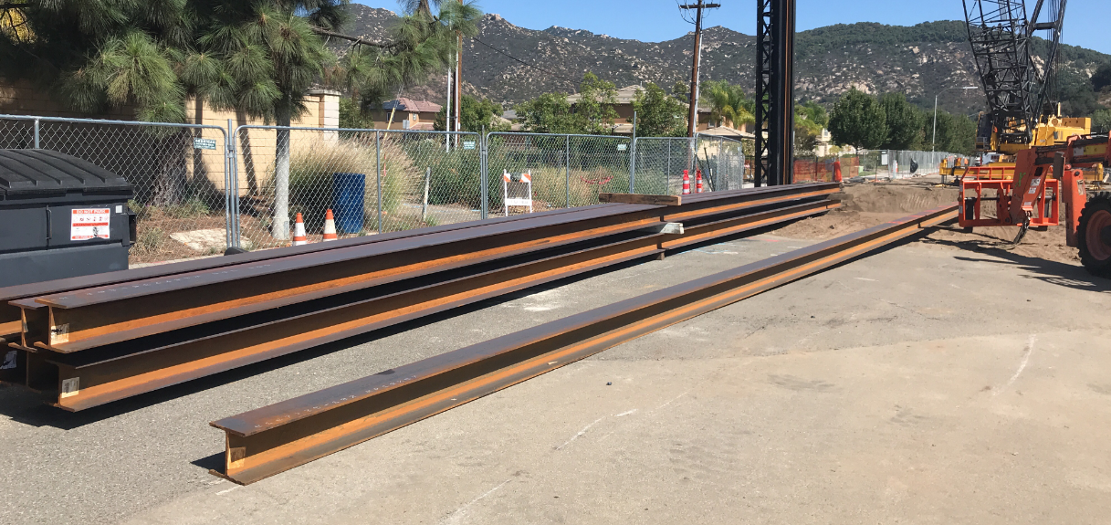
Figure 3 –75’ Piles
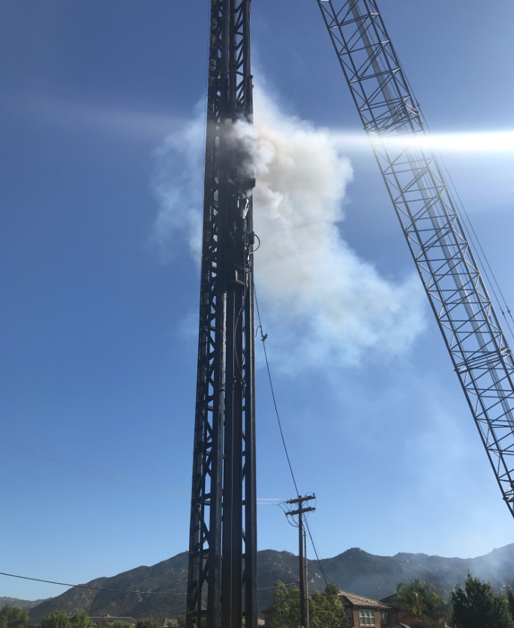
Figure 4 –Driving Piles

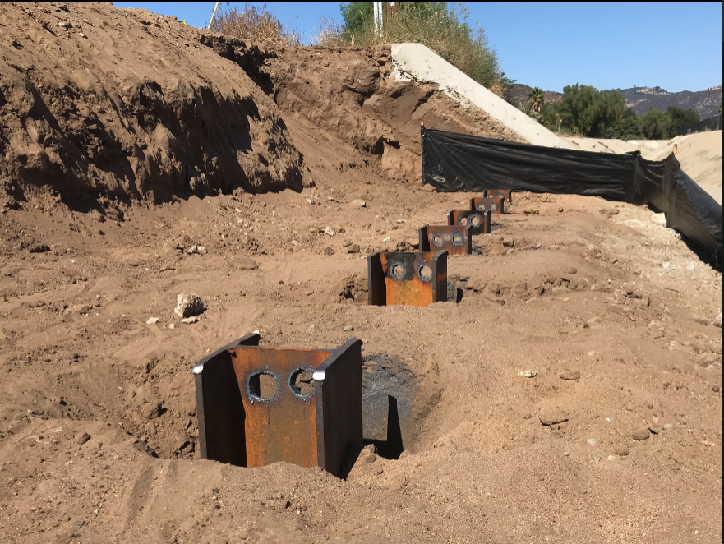
Figure 5 -Driven Piles East of Creek
The contractor has begun forming the foundation for the new bridge.
Project Questions/Concerns:
- John Houston, City of Escondido Field Engineering Inspector
Office: (760) 839-3811, Email: jhouston@escondido.org
- Jorge Rivera, Contractor Contact, Hazard Construction
Office: (858)587-3600 Ext. 180 , Email: JRivera@hazardconstruction.com
- Please note: To report non-emergency traffic safety issues outside of our normal working hours, and you feel this requires immediate attention, please contact our Non-Emergency Escondido Police Dispatch @ 760-839-4722. When calling this number, please press "9" to speak with a live dispatch operator. Dispatch is available 24 hours a day, 7 days a week.

