Purpose:
The El Norte Parkway Improvement Project will construct new improvements in the area of the Escondido Creek Channel, bringing El Norte Parkway to its ultimate width to improve traffic flow. The Project will also add landscaped medians along El Norte Parkway between El Norte Hills Place and East Valley Parkway. A signalized pedestrian crossing will be added to increase pedestrian safety and welcome users at the existing bike path where the Escondido Creek Trail crosses El Norte Parkway. The new trailhead entry sign will be installed where the Escondido Creek Trail crosses El Norte Parkway.
Schedule:
September 2019 – March 2020
Features:
- Construction of second bridge over the Escondido Creek
- Addition of another lane in each direction on El Norte Parkway
- Construction of landscaped medians
- Undergrounding of existing overhead utilities
- Signalized pedestrian crossing
- Escondido Creek trailhead entry sign

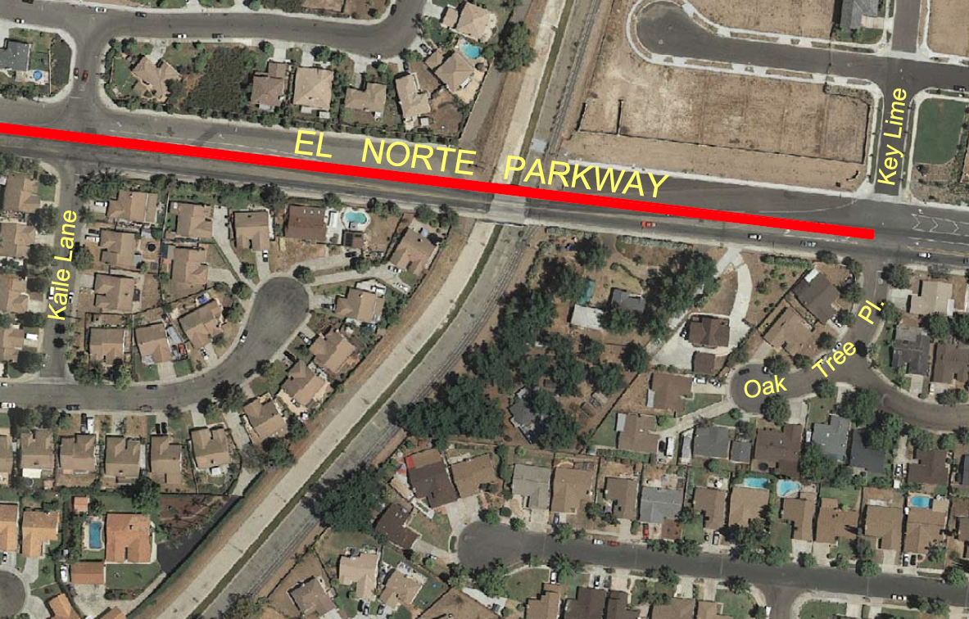
Location Map
Project Update:
November 2019 – Update
Figure 1 illustrates a 400-ton crane that was used to lift the bridge girders in place. Six bridge girders were delivered and installed as seen in Figure 1.
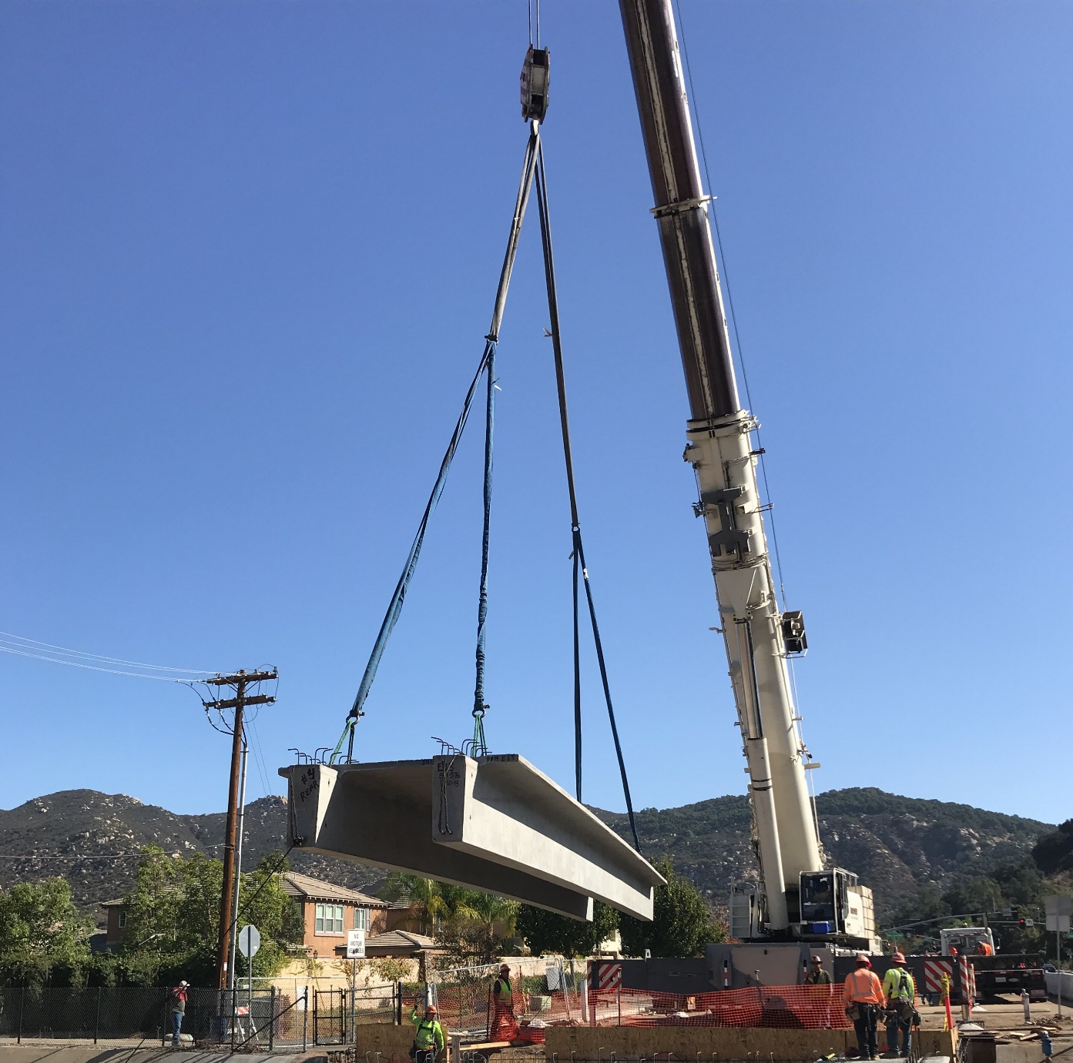
Figure 1
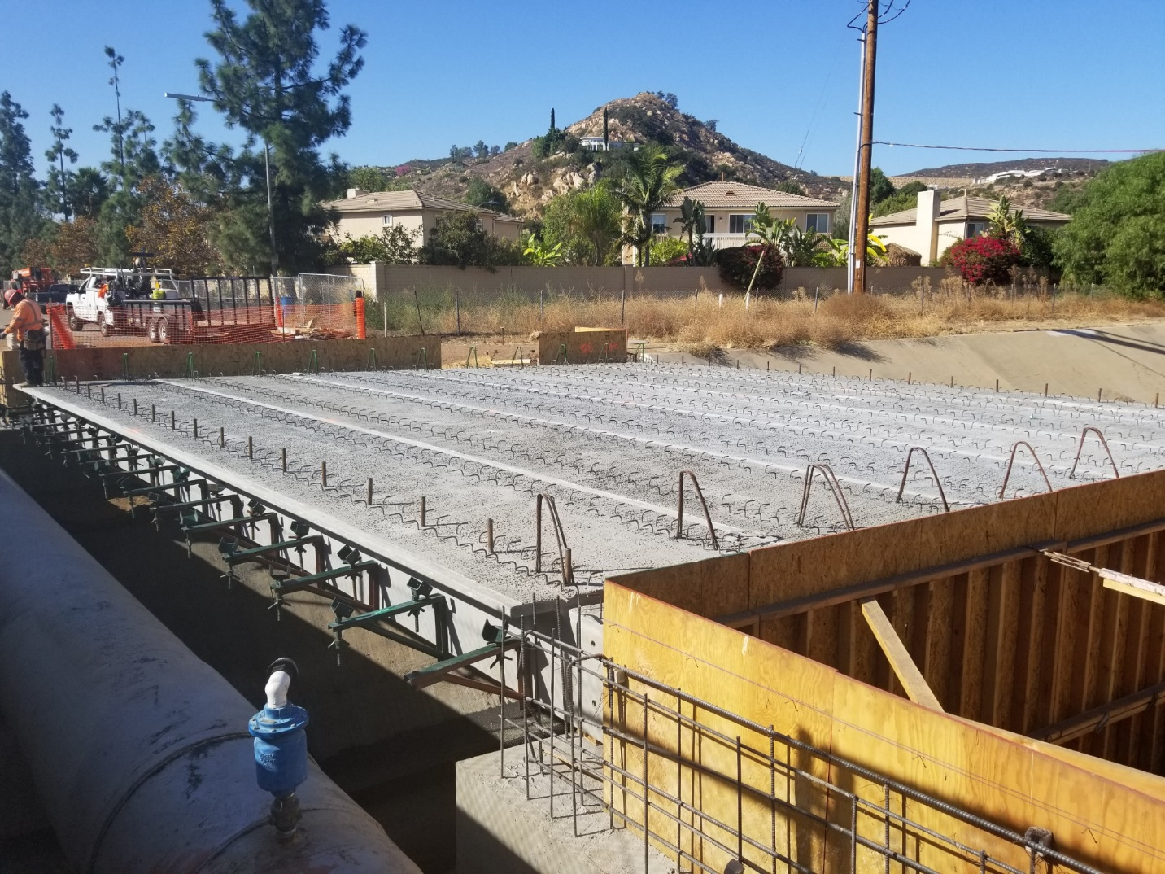
Figure 2
Contractor will begin construction of the median on El Norte Parkway on November 12, 2019. They are anticipating pouring the bridge deck November 25, 2019.
Project Questions/Concerns:
- John Houston, City of Escondido Field Engineering Inspector
Office: (760) 839-3811, Email: jhouston@escondido.org
- Jorge Rivera, Contractor Contact, Hazard Construction
Office: (858)587-3600 Ext. 180 , Email: JRivera@hazardconstruction.com
- Please note: To report non-emergency traffic safety issues outside of our normal working hours, and you feel this requires immediate attention, please contact our Non-Emergency Escondido Police Dispatch @ 760-839-4722. When calling this number, please press "9" to speak with a live dispatch operator. Dispatch is available 24 hours a day, 7 days a week.

