November 9, 2018 – Second Project Update
Majority of the work on the new Class IV two-way bikeway cycle tracks along W. Valley Parkway and portion of Broadway has been completed. New green bollards were installed to provide separation between the general traffic and the new two-way bikeway cycle tracks, as well as new striping and signage to alert drivers about bicyclists going in both directions (Figure 1). New traffic signal indications for bicyclists going eastbound on the bikeway have been installed at three traffic signals on W. Valley Parkway (Figure 2).
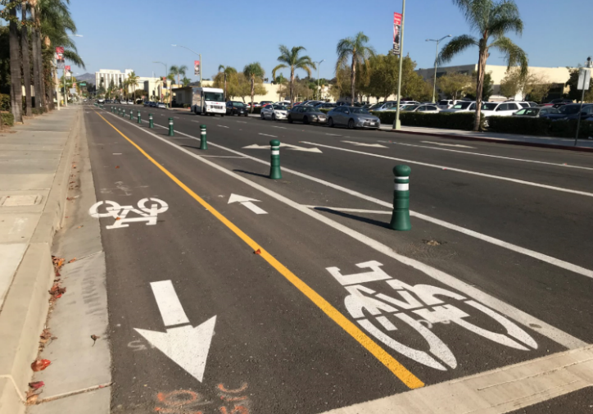 | 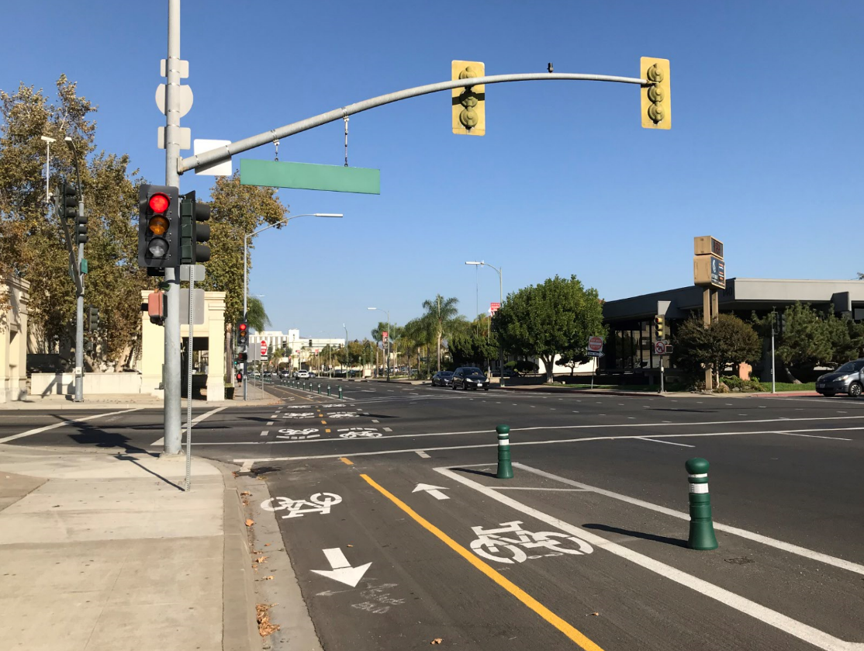
Figure 1 - Class IV two-way bikeway on Valley Parkway | Figure 2 - New traffic signal indications for bicyclists going eastbound on the bikeway

The Contractor has completed the construction of the new bus stop platform and raised medians at the NCTD bus stop on Valley Parkway and Orange Ave. Buses no longer require to cross the bikeway for loading and unloading passengers. Crosswalk striping has been provided for passengers to cross the new bikeway at the new bus stop platform (Figure 3).
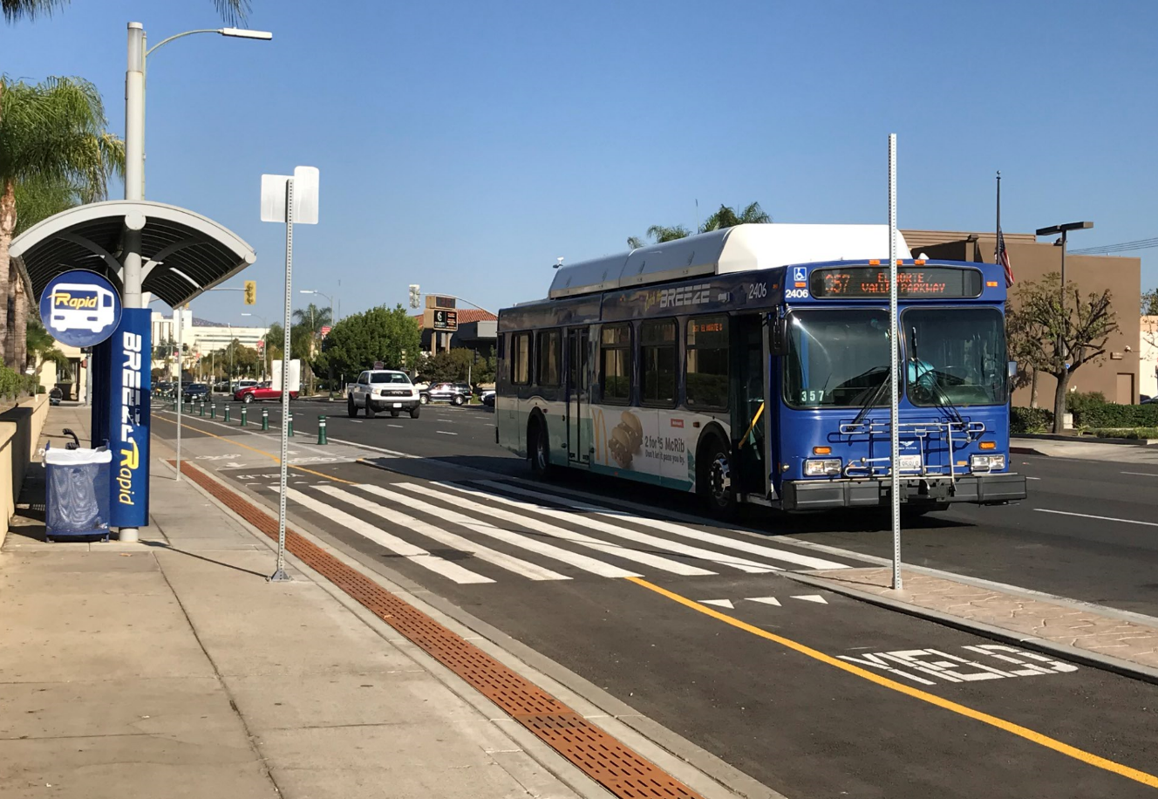
Figure 3 – Bus Stop Platform with crosswalk
Two new pedestrian ramps and a raised median have been constructed for the signalized pedestrian crossing on Broadway between Grape Day Park and the San Diego Children’s Discovery Museum (Figures 4-6). The traffic signal sub-contractor has installed the foundations for the new traffic signal poles and will install the poles when the equipment is delivered.
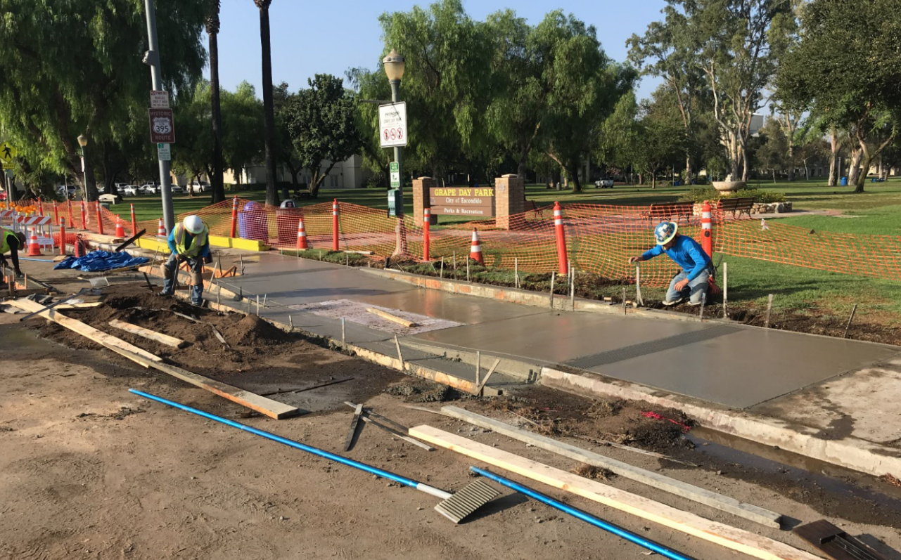 | 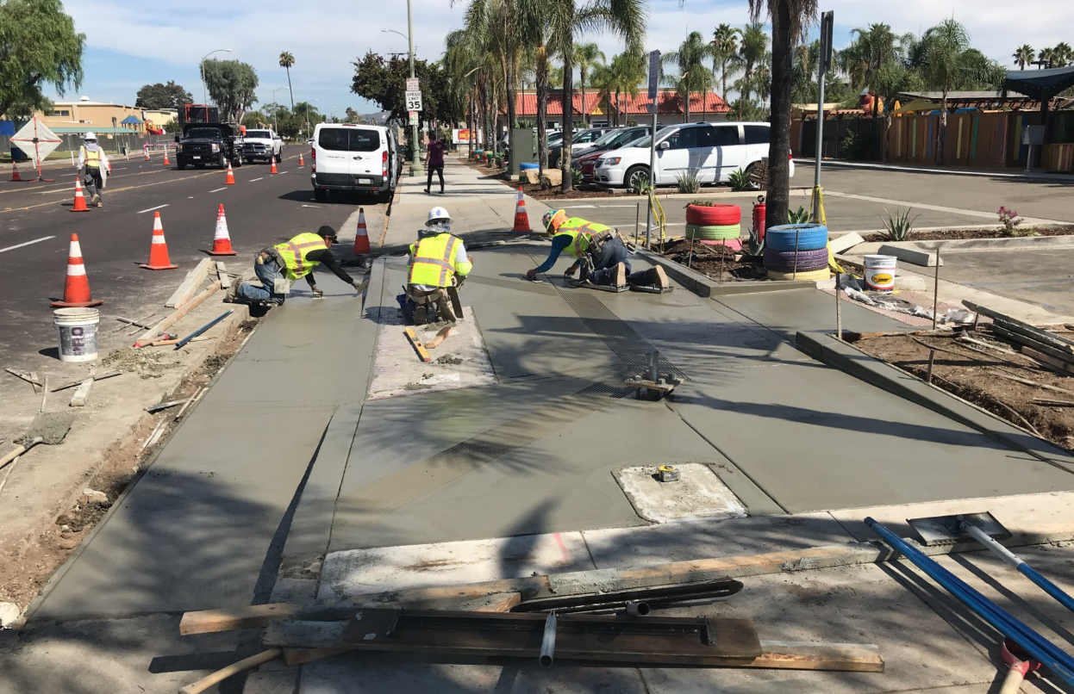
Figure 4 – Pedestrian ramp by Grape Day Park | Figure 5 – Pedestrian ramp by San Diego Children’s Discovery Museum
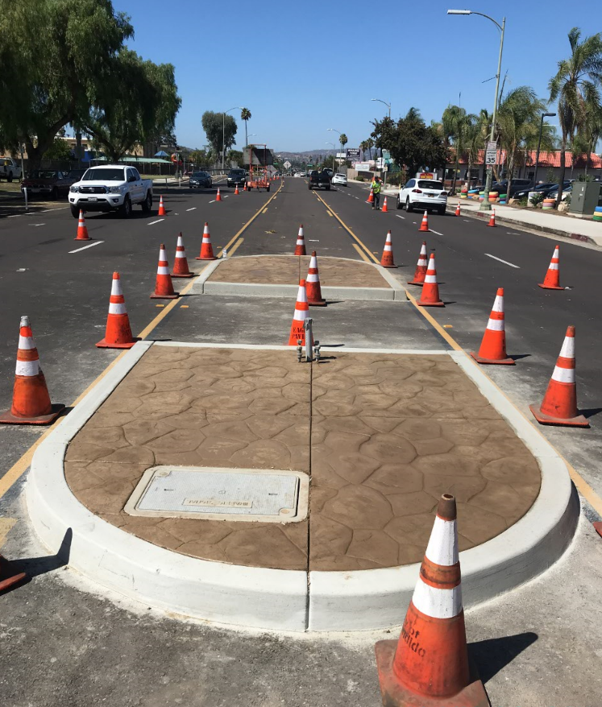
Figure 6 – Raised median on Broadway

Work on the bike and pedestrian bridge on Broadway has begun. The two abutments for the bridge were formed and concrete was poured (Figures 7-9). The Contractor will backfill the area around the abutments and get the site ready for the installation of the prefabricated pedestrian bridge that will be delivered in late November.
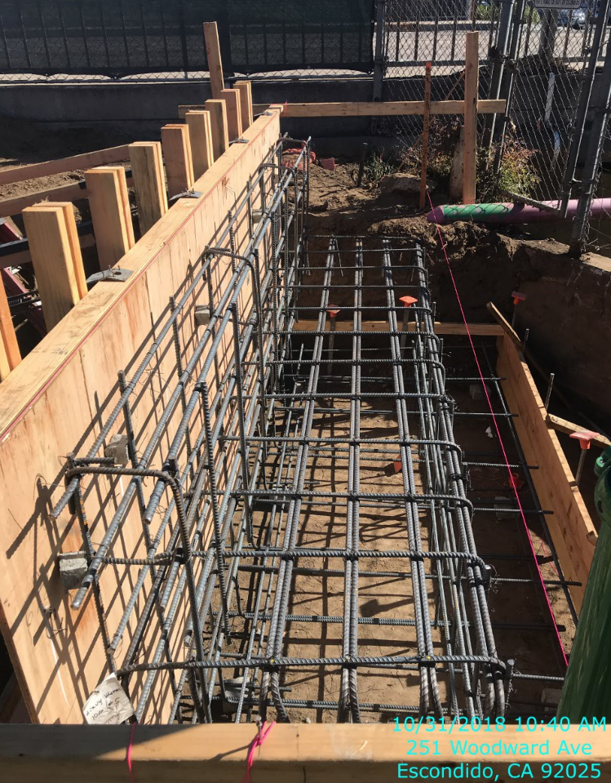
Figure 7 – Bridge abutment #2 reinforcement
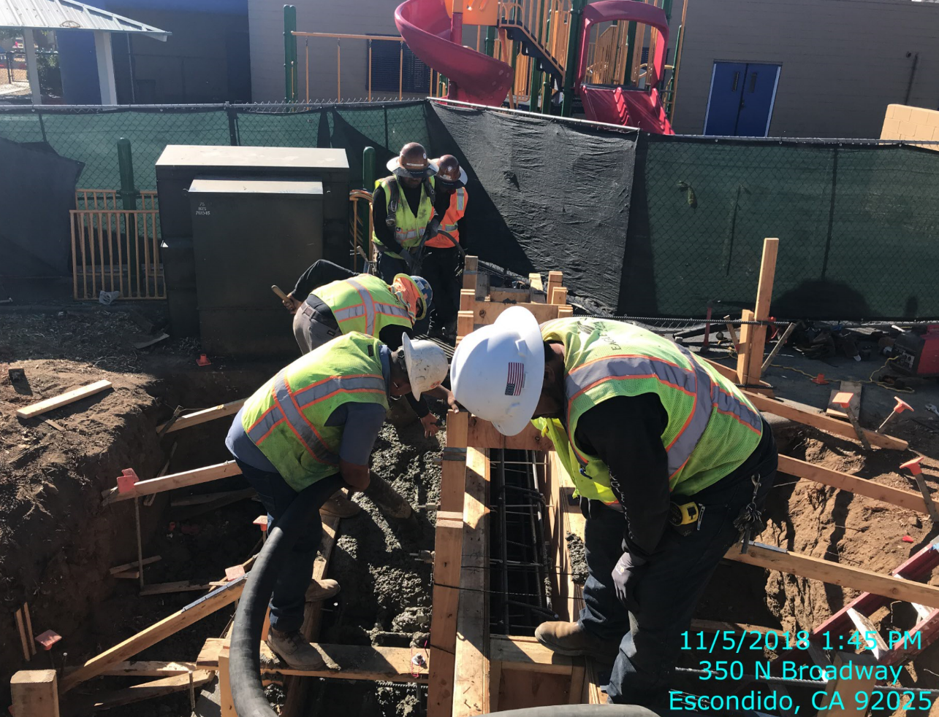
Figure 8 – Concrete pour at bridge abutment #2
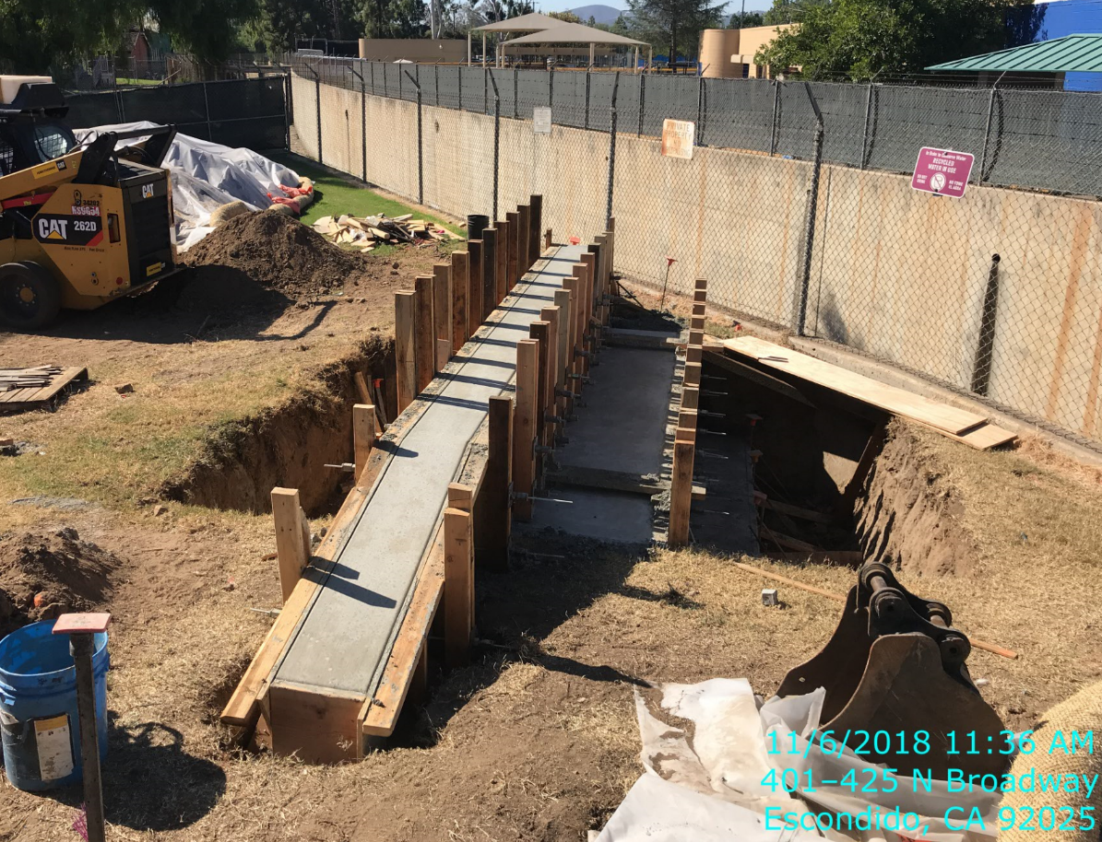
Figure 9 – Bridge abutment #1 formed and concrete poured

